
NORTH SOUTH UNIVERSITY
Committed to the highest standards of academic excellence
School of Engineering and Physical Science Department of Mathematics & Physics
Assignment-01
Semester : Spring 2023

Faculty : Dr. Rubaiyet I. Haque (RUH)
Email: rubaiyet.haque@northsouth.edu

Course Name and Course Code:

Physics – I, PHY 107

Date:18/02/2023

Ans to the q. no.01
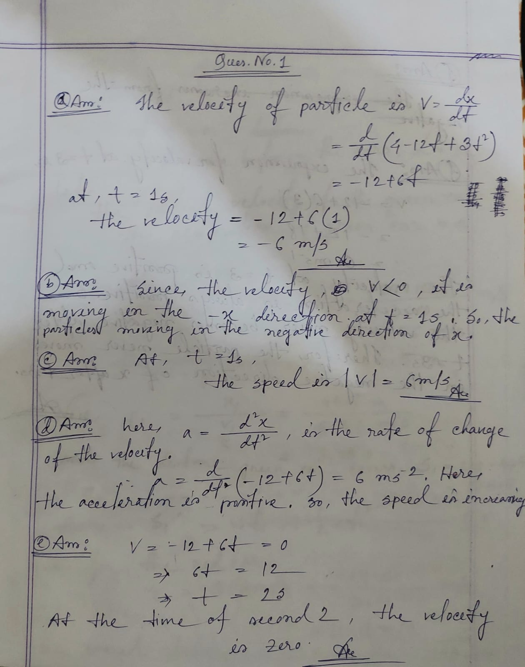

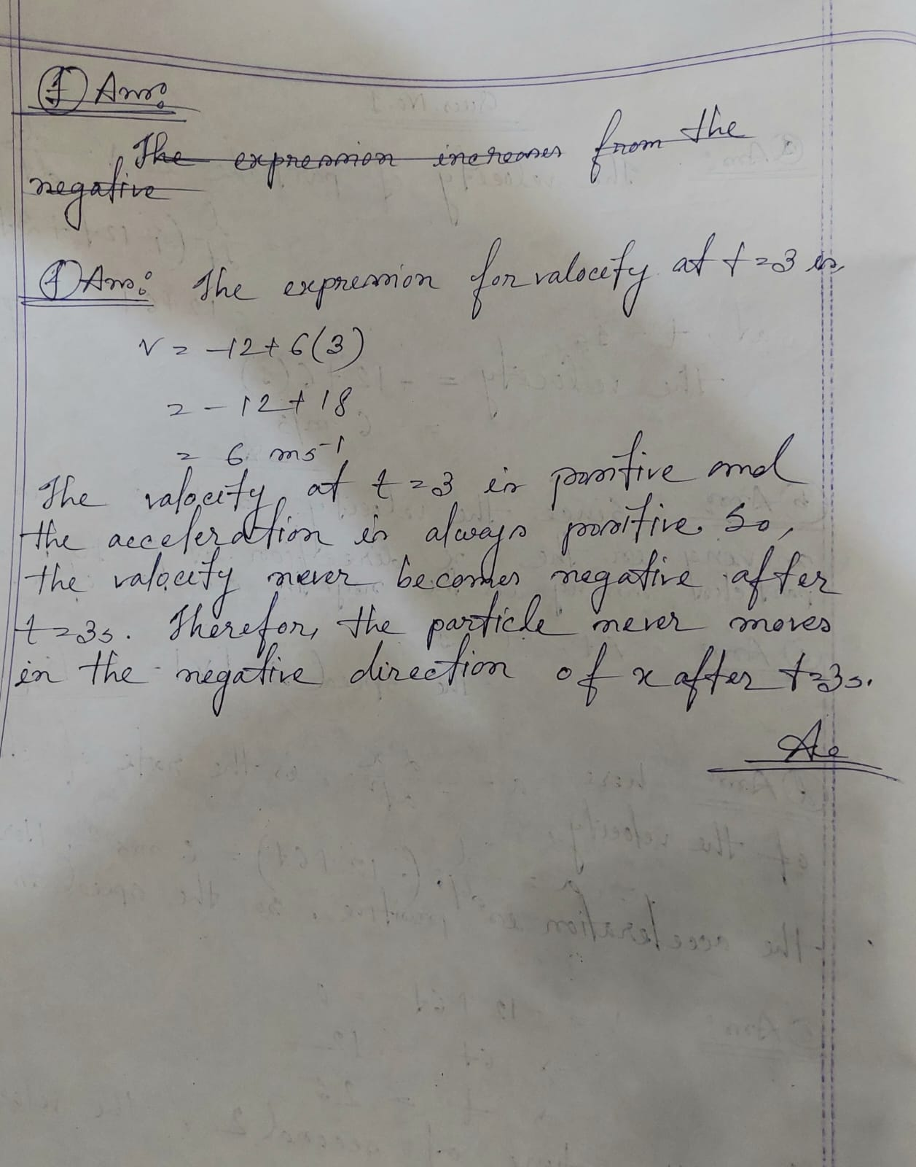

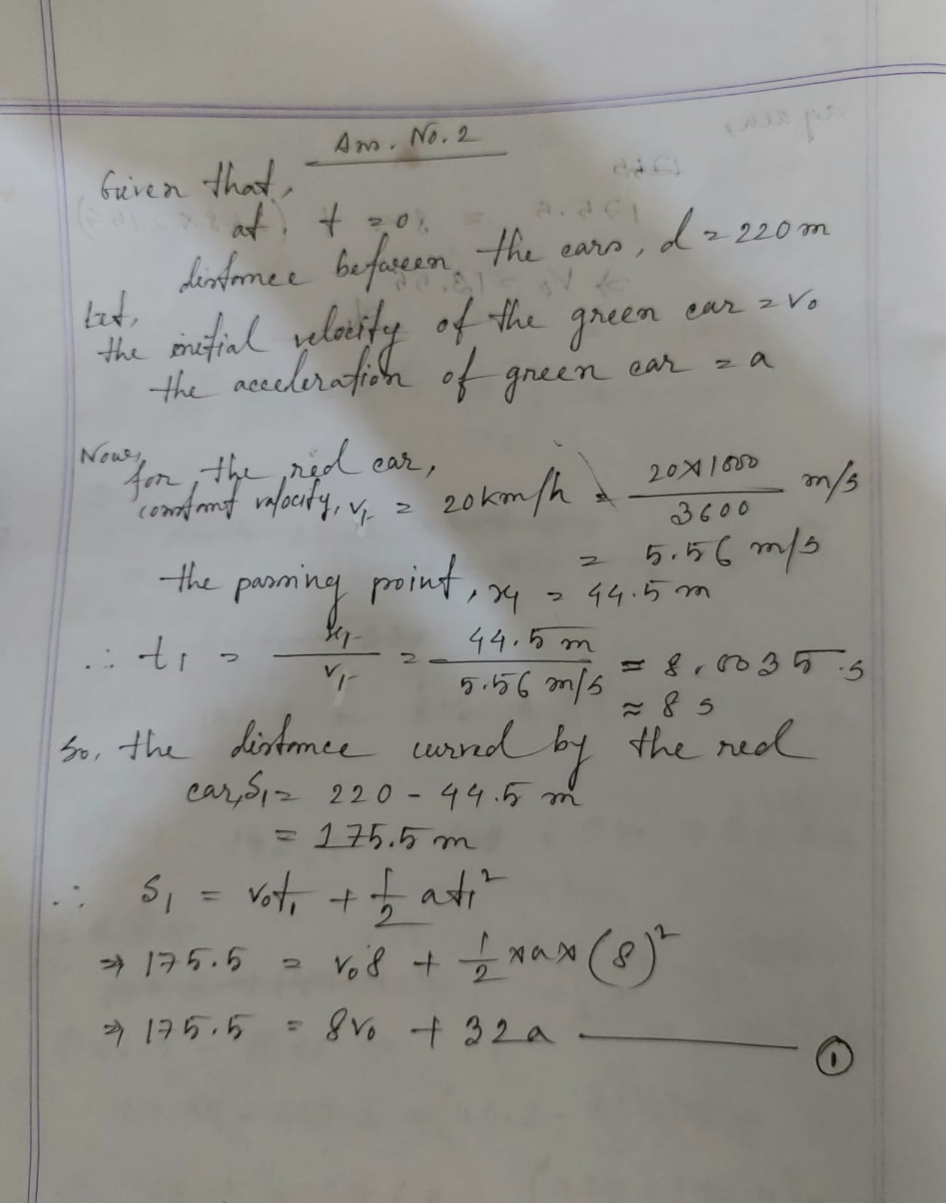
Ans to the q. no.02

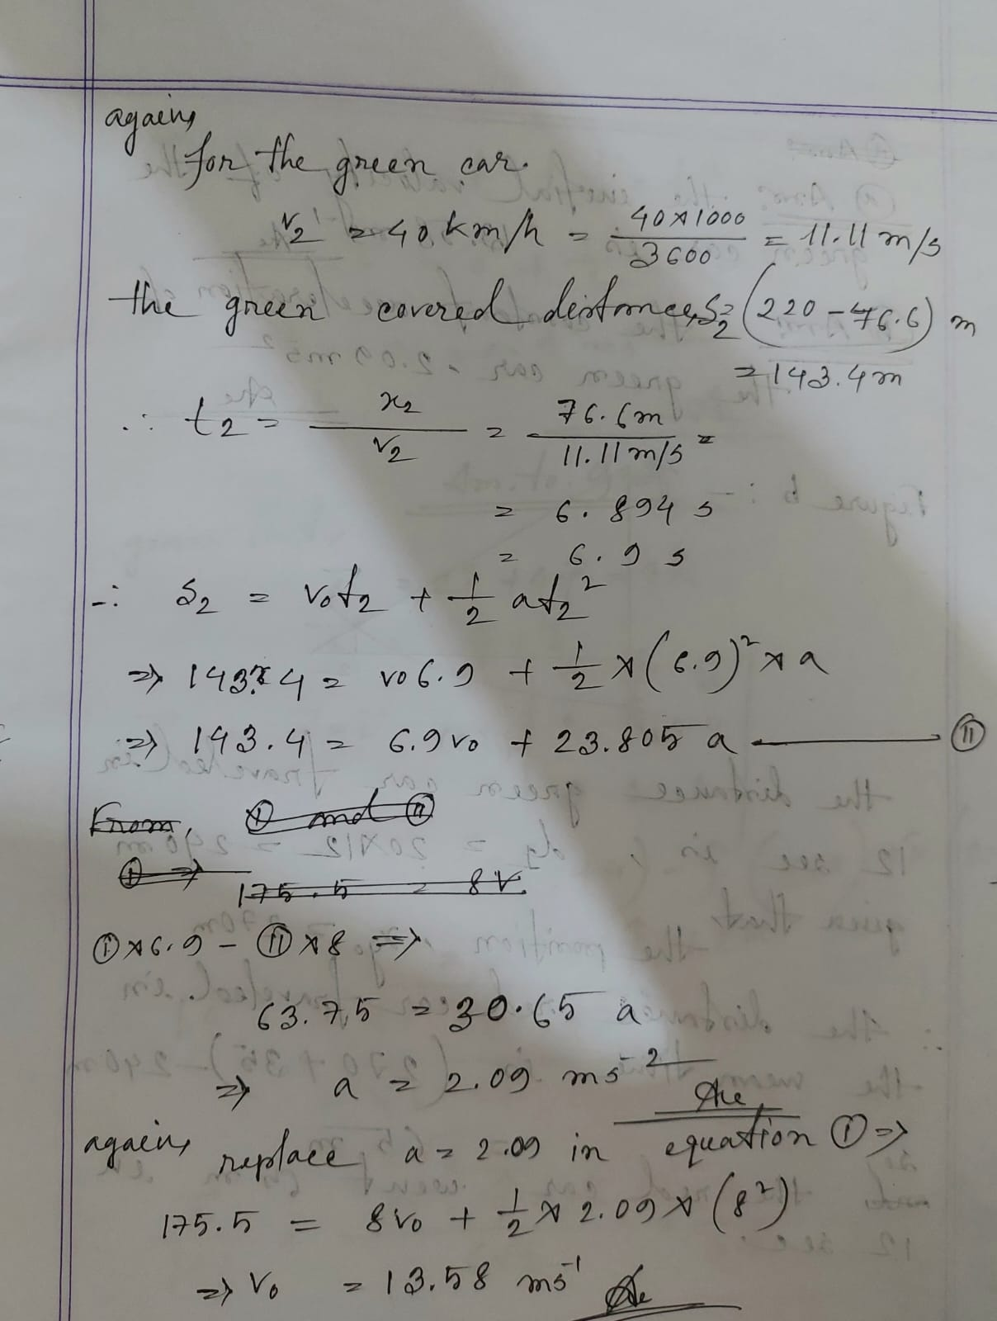

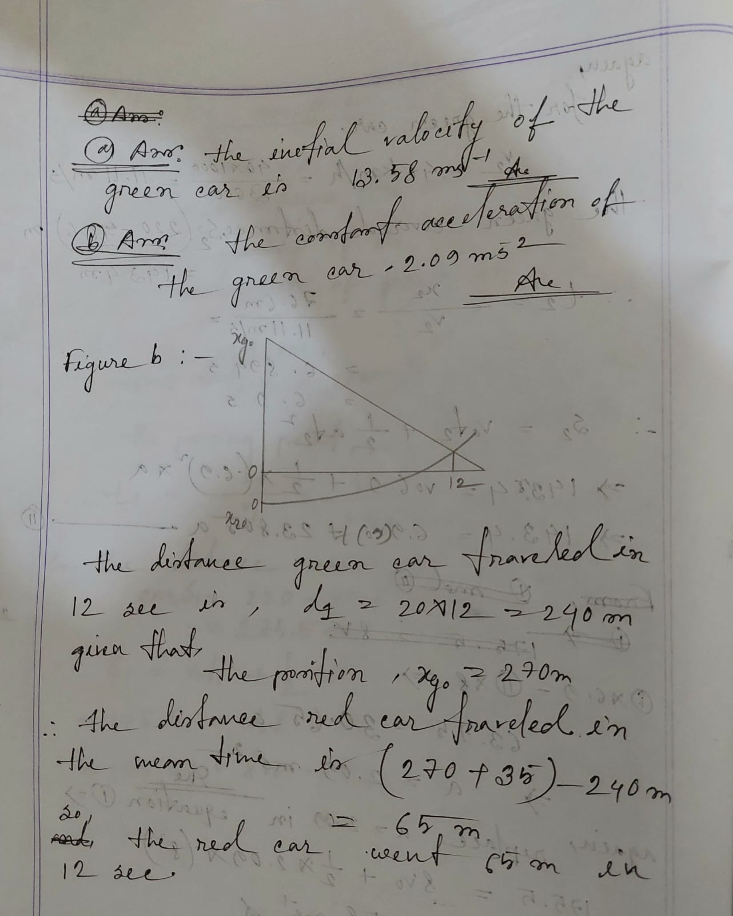

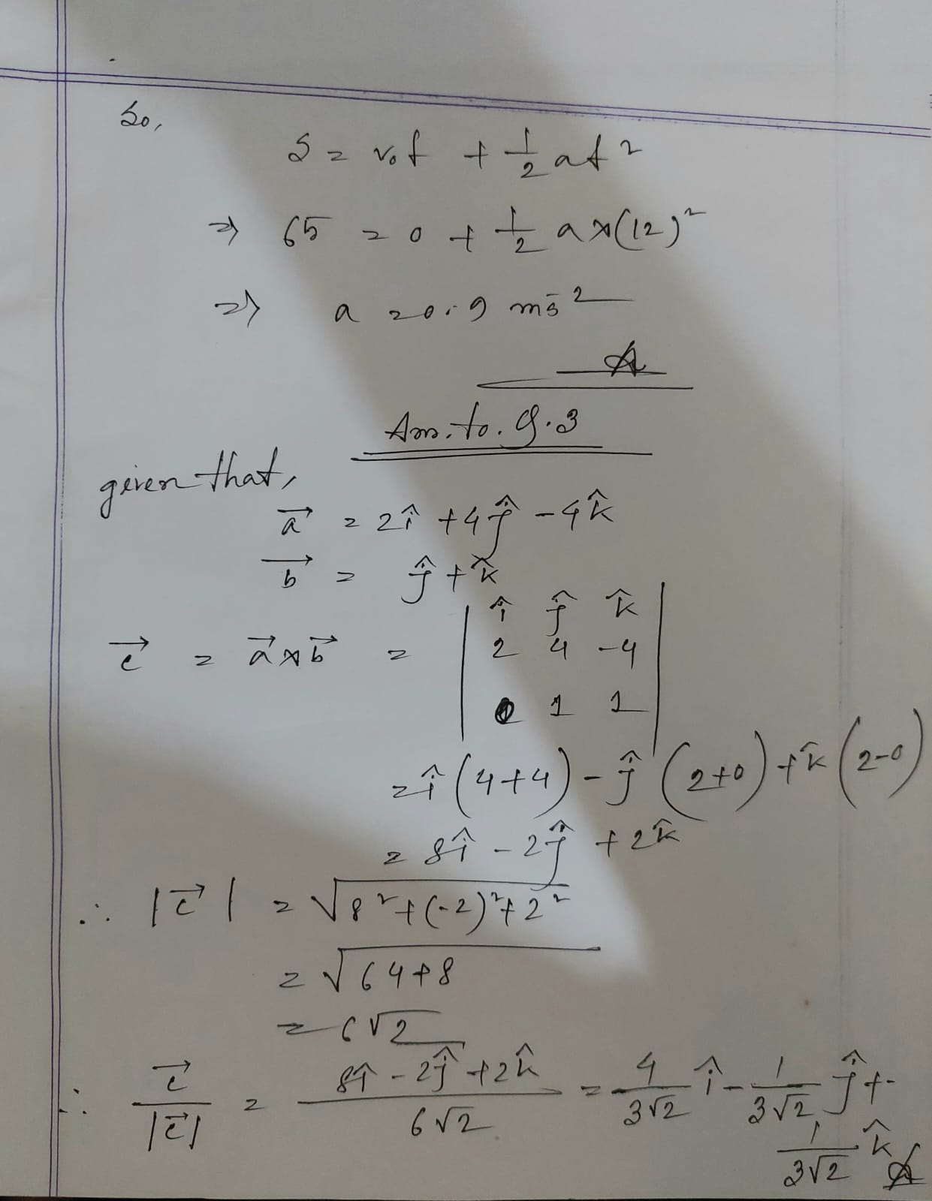
Ans to the q. no.03

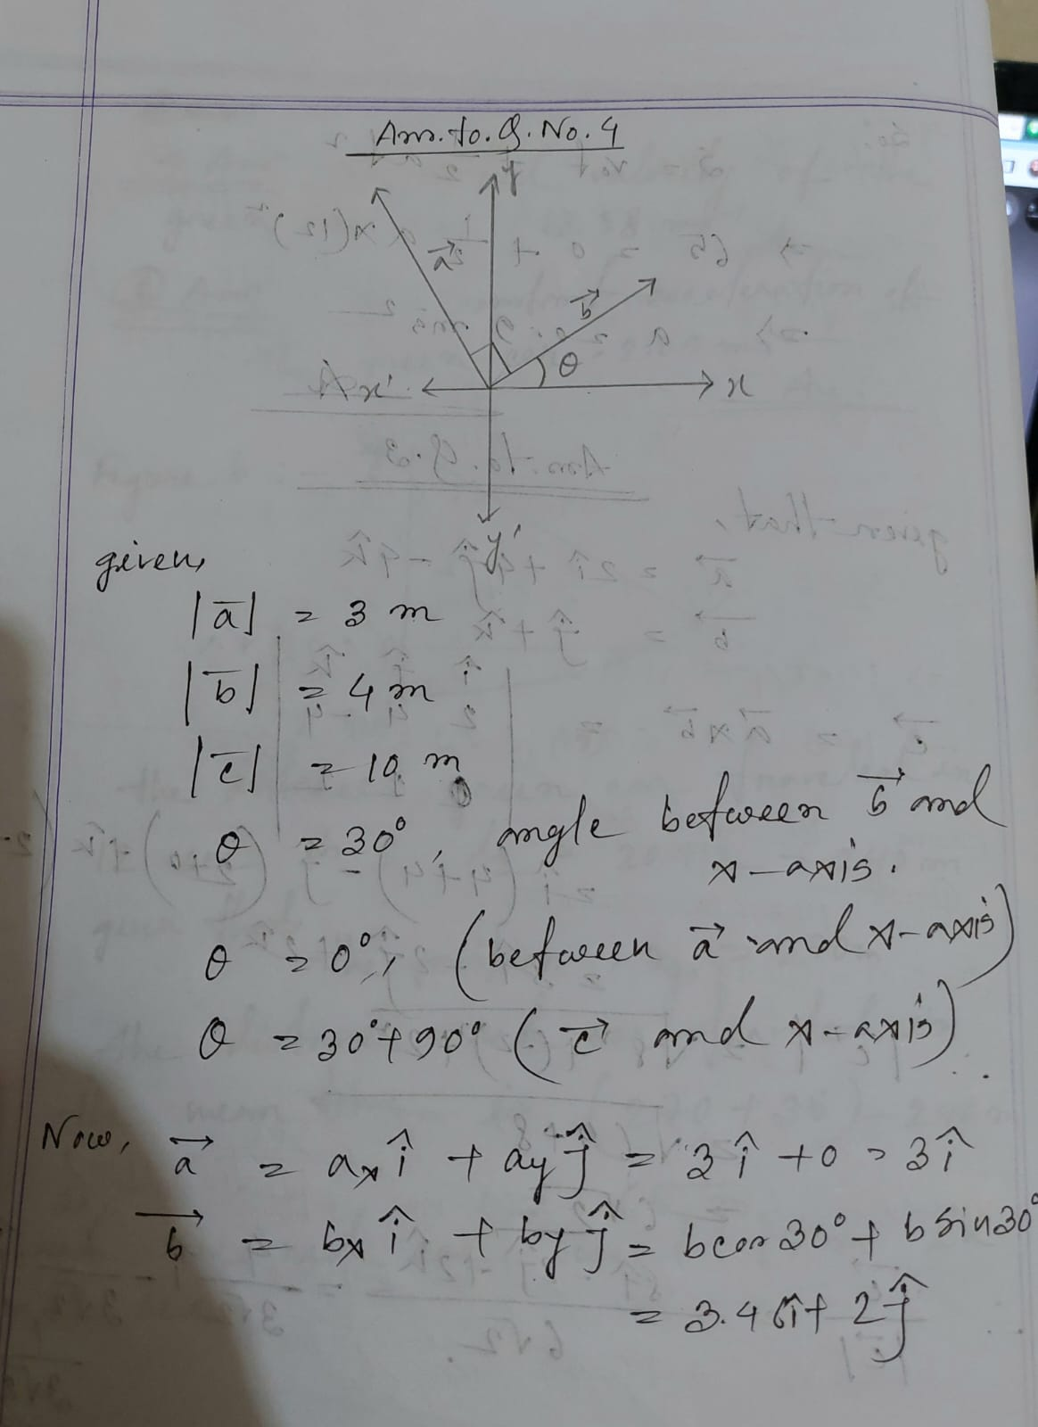
Ans to the q. no.04

